FOAM PAD FOR COVERSLIPS

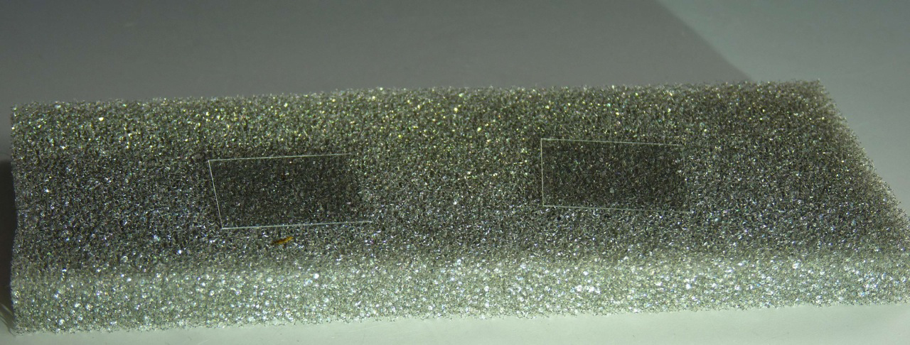
Handling coverslips that are used repeatedly is facilitated by small piece of polyurethane foam on the lab bench. A small piece, 5 cm X 10 cm and .5 to 1 cm thick is all that is needed for two or three coverslips. Keeping the coverslips on the foam makes them easy to pick up by pressing thumb and finger into the foam on either side of the coverslip. The coverslip is then transferred to forceps for careful placement on the slide. This way coverslips are always handled by the edges so fingerprints are avoided.

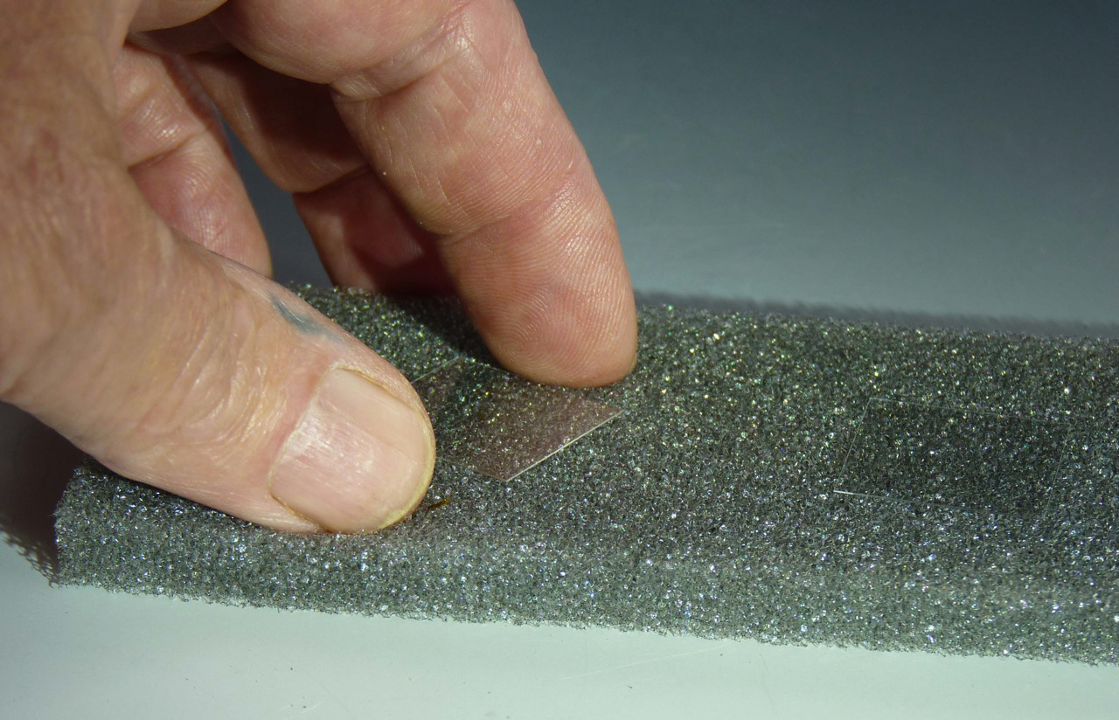
Standard microscope slides can be placed on a foam pad the same way as coverslips but I prefer to keep them flat on the lab bench. This prevents the drop of water for mounting leaves from getting get tipped off. After placing the coverslip on the mount I slip the slide to the edge of the bench to put them on the compound microscope stage. Otherwise, as often as not, the water drop is not added to the slide until it is on the stage of the dissecting microscope and dissections are complete.

COVERSLIPS AND SLIDES IN BOX

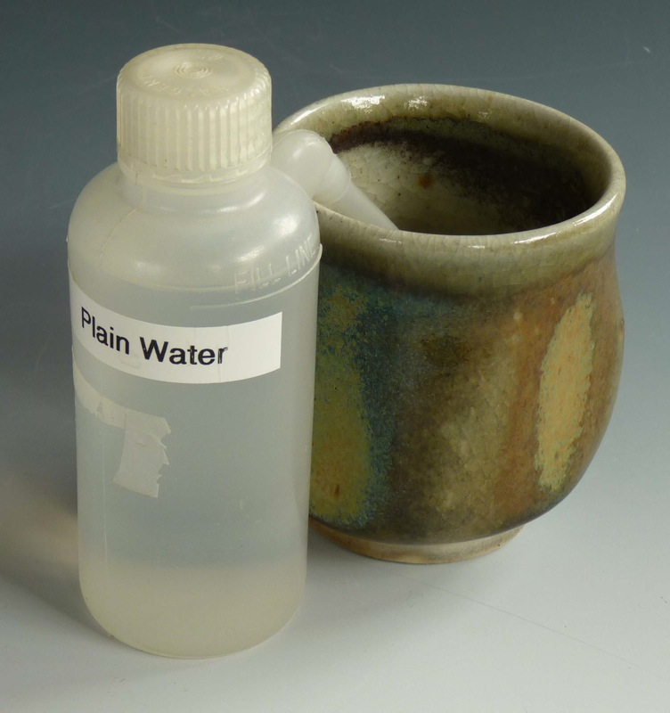
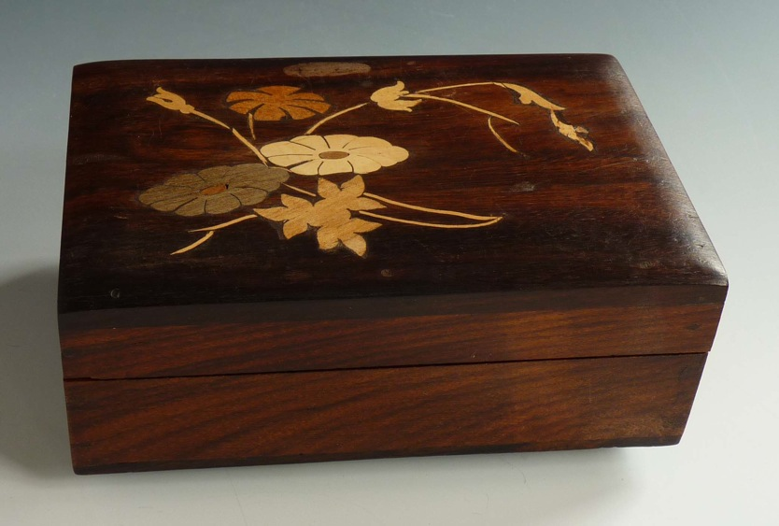
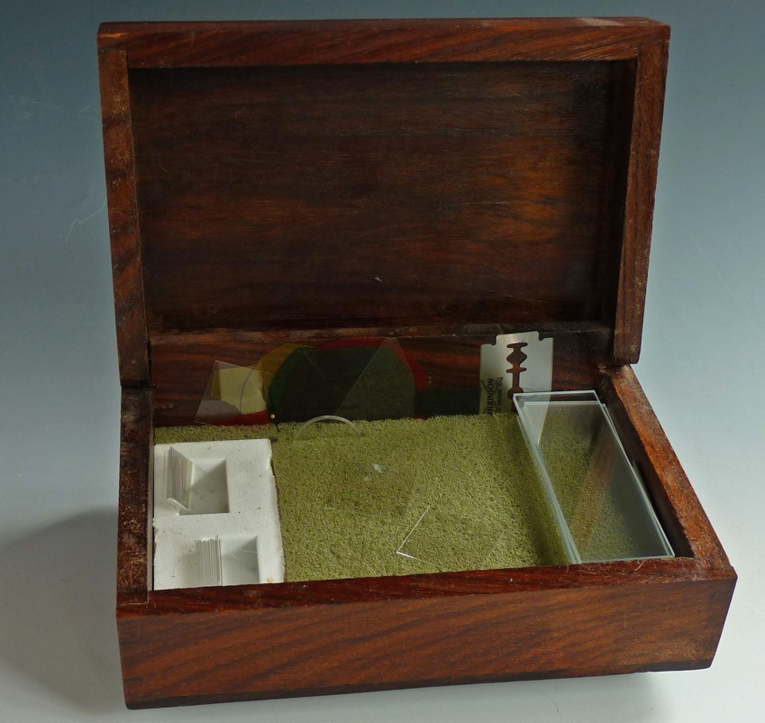
I keep my foam pad with coverslips in a wooden box, so that when I'm away from the bench for a period of time I can close the lid to keep dust off the coverslips. I have cut out a place at one end to store a small stock of coverslips and stack a similar stock of slides at the other end of the box. A reticle for measuring or counting is tucked into a slot in the foam at the top. A fresh razor blade is can be stored along the top edge. My box is not just any old cigar box, it is a box made by a craftsman. It is a way to have an article of beauty on my lab bench, something important to me as a scientist with an active aesthetic sense.

WASH BOTTLE FOR SPECIMENS AND SLIDES

It is beneficial to have a small (125 ml/4 oz) wash bottle handy on the bryological bench for first rinsing off specimens for study and then for washing off slides and coverslips for reuse. Rinsing a specimen fragment gets rid of extraneous dirt and debris that might cling to it when it is removed from its substrate. It also dilutes the wetting agent if such has been used to rehydrate a dried specimen. Washing out excess wetting agent keeps the water drop mount from running all over the slide before the coverslip is applied. The shoot is held over a small cup so the wash water is contained. I like to use a pretty, wood-fired stoneware cup, much more pleasing to the eye than the usual beaker.

SELF-FOCUSING FOAM STAGE FOR A DISSECTING MICROSCOPE

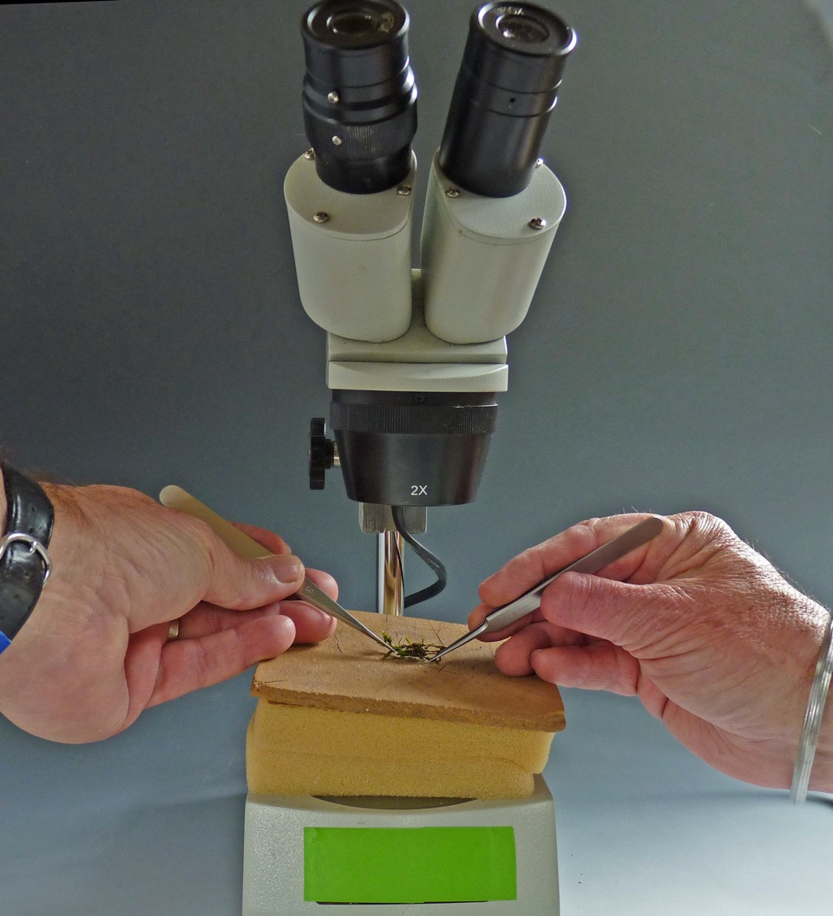
When working with bryophytes one is often faced with making delicate dissections of very small plants, looking for the location of sex organs or other critical parts. High magnification helps in this work but has the disadvantage of having to work with shallower depths of field as magnification level is increased. When picking down through a tiny colony with a pair of watchmaker's forceps in each hand it is easy to get out of the working plane of focus. At this point it is difficult to put one forceps down in order to turn a focusing knob without losing sight of the part being worked on. This matter caused me much frustration when I began working with liverworts, looking for underleaves or leaf insertion point as well as antheridia. The challenge was to change focus without letting go of the plant I was dissecting using both hands.

Foot controlled, electric focusing stages are available but are very expensive. My solution is to place a stack of foam pads on the stage of the dissecting scope with a cork board on top. I set the focus of the scope just at the surface of the cork board. This way I can focus on any part of a specimen by pressing down on the board with the heels of my hand while examining it with needle and forceps. It is easy to tip a specimen from side to side while keeping a particular point of interest in view and in focus even with magnification set at the highest level. Most of the time now, I never touch the focusing knob when studying specimens. I need manipulate only the rotating objectives or the zoom knob to change magnification level.
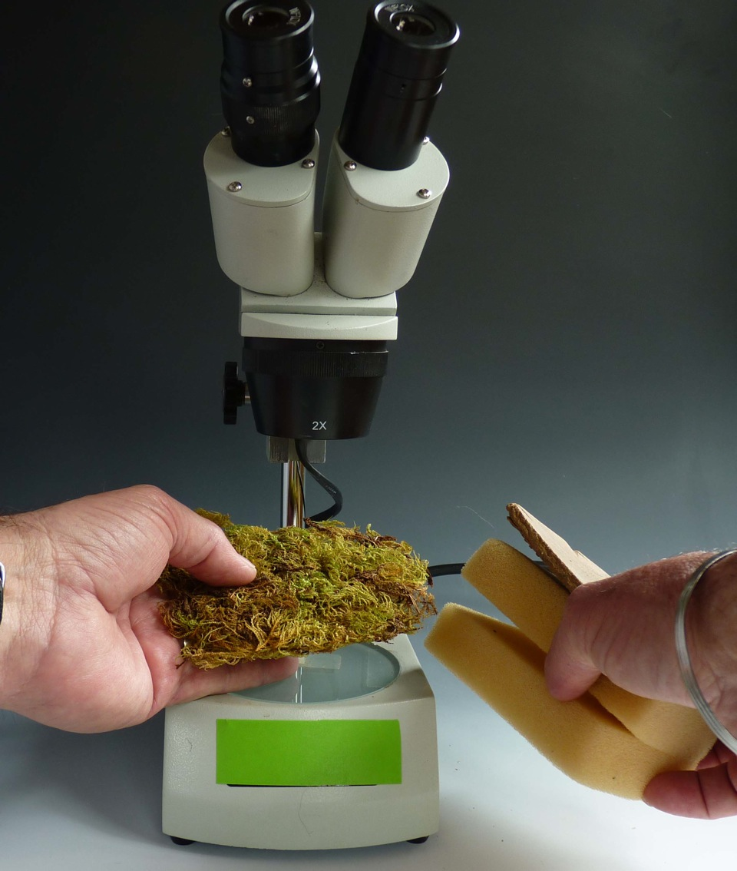
An ancillary advantage to this system of focusing is its facility for quick examination of large hand samples. By simply setting aside the foam focusing stage, a bulk sample can be held under the objective, examining all parts of the sample by moving it around to different parts while at the same time shifting it up and down to focus on points of interest. This is important when searching for reproductive structures that are sparse in the colony being examined.

THREE TIPS

One of the wonderful things about teaching is learning from your students. In the past year or two, I've picked up three good lab hints that are worth sharing.

The first is the needle dropper bottle brought to one of my workshops by a clever participant. A picture is attached. Cost is $3 to $4 each. These are made by Gaunt Industries and available directly from them:
http://www.gauntindustries.com/2_Ounce_Products-HYPO_25.html
or from a plastics fabrication store such as Tap Plastics (21 stores in Pacific States):
http://www.tapplastics.com/shop/product.php?pid=409&
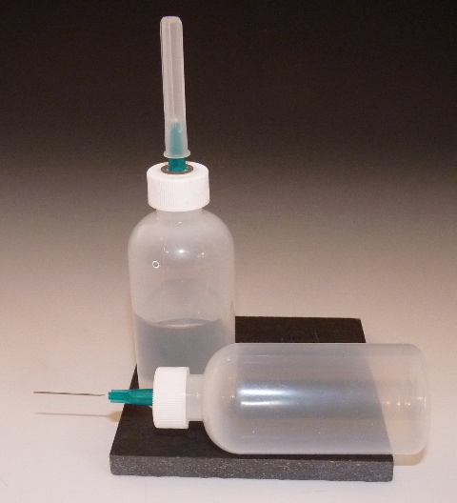
or from art supply stores. Ceramic stores tend to have bottles with large diameter needles but the ones with 23 gauge needles are best. I keep one each for plain water and for Pohlstoffe (water with wetting agent). They allow precise placement of a small amount of water on a slide or controlled application of Pohlstoffe on a dry specimen. One great benefit is that if you knock a bottle over, liquid is not spilled all over your microscope bench.

Needle dropper bottle

Pohlstoffe is an informal name for a wetting agent concocted from a Fisher Science product called Aerosol OT. A half dropper of their 10% solution in a dropping bottle of water (ca. 50 ml) is excellent for wetting bryophyte specimens, especially useful for capsules and other hard-to-moisten parts (Wagner, D.H. 1981. Pohlstoffe, a good wetting agent for Bryophytes. The Bryologist 84: 253.) The Fisher proprietary solution is not always easy for amateurs to obtain. But one of my students pointed out that the critical substance is also known as docusate sodium, the active ingredient of stool softener! I went to the local discount drug store and bought a 60 caplet bottle for less than $5. A little testing showed that one caplet (100 mg docusate sodium) punctured and squeezed into one ounce (25 ml) of water makes a very satisfactory Pohlstoffe! The tiny amount of carriers (glycerine, gelatin, propylene glycol, polyethylene glycol) leaves no noticeable residue. IMPORTANT: USE GEL TABS, SOFTGELS, NOT SOLID CAPLETS.

The third hint also relates to a simple source of a good stain for Sphagnum, Methylene Blue. This is used by fish fanciers as antibiotic to stave off infections when hatching fertile fish eggs and is readily available at tropical fish stores. A 1/2 ounce bottle (ca. 12 ml) of a VERY concentrated solution cost $4.25, a lifetime supply for me.

MAKING SLIDE MOUNTS WITH GLYCERINE

In general, when people speak of making slides permanent they expect the end product to be durable and resistant to being tossed around, like old fashioned balsam mounts or ones made with contemporary synthetic resin equivalents like Permount. To make these mounts it is necessary to dehydrate the specimen in an alcohol series until it may be infiltrated with an organic solvent like xylene that is miscible with the resin. This is not a reasonable method for dealing with preserving wet mounts of small objects. And it means working with xylene, far more toxic than we thought 40 years ago.

I make slides permanent using plain glycerine. The mounts are relatively fragile and must be stored flat but are nevertheless permanent in the sense that the material is preserved indefinitely without significant deterioration of the specimen. I have used Hoyer's in the past but find that it is far too likely to distort specimens by drying and/or crystallization. Bryological material in Hoyer's, especially thin cell walled liverworts, is cleared to the point of near transparency and thus becomes nearly invisible.

If I have a slide of leaves or leaf sections I want to preserve, or even a whole mount of a small plant, I simply put a line of glycerine across one side of the coverslip and set it aside overnight. (Label the slide immediately!) As the water evaporates from one side of the coverslip, the glycerine is drawn in and gradually infiltrates the specimen. No special technique is required although the process may be speeded up if the slide is put on a warming tray.

Exactly how much glycerine to apply must be determined by practice and varies depending on the thickness of the object under the coverslip. A single drop is enough for a thin mount consisting mainly of leaf sections. It is important to use enough glycerine at the outset because if there is not enough, air will be drawn under the coverslip as the last of the water evaporates. If more glycerine is added later, bubbles are likely to form which are nearly impossible to eliminate. For this reason I tend to apply glycerine generously at the outset. After the slide is completely infiltrated with glycerine (overnight or longer) if I see there is an excess of glycerine I blot it with little strips (5 mm X 20 mm) of tissue paper. For blotting I prefer strips of toilet paper or something like Kleenex tissue because it absorbs much better than Kimwipes or other lint free industrial wipes. The lint free wipes are critical for cleaning slides and coverslips but just do not wick the glycerine as fast. I keep wicking, using as many strips as needed, until the glycerine just starts to draw back from the edge of the coverslip.

At this point the preparation is as permanent as it will ever be but it is not very robust. The coverslip is easily dislodged as it is floating on a film of glycerine. The preparation can be made quite durable by painting a strip of clear fingernail polish on the two sides of the coverslip facing the length of the slide. I spread it well away from the edge of the coverslip to give the polish traction. It dries quickly and then is really quite durable. I do not completely ring the slides with nail polish; the sides are left open in case some of the glycerine leaks out and needs to be replaced. The nail polish will not stick to a slide where there is a film of glycerine so it may be necessary to carefully clean up the slide with a cotton swab moistened with alcohol or wetting agent.

Speaking of leaking: glycerine has a nasty habit of creeping out from under coverslips if the edge of the coverslip is too close to the edge of the slide. This happens fast when two slides come in contact side to side. If the coverslip is close, the glycerine will creep to the edge of the slide and then capillarity will pull it down between the slides and under them. It takes only a few weeks (days?) for all the glycerine to be sucked out of a poor mount. The critical point is that the coverslips must be perfectly centered on the slide before the nail polish is painted on. It is best to center the coverslip right after the glycerine has been applied to the coverslip, before it is set aside for drying and infiltration. Remember that the nail polish must not be applied until the glycerine mount has dried thoroughly, at least overnight.

The prepared slides are stored on trays the size of plant press boards so they fit in a herbarium cabinet neatly. Three rows fit in nicely lengthwise down the tray. I made some very nice ones from foam core board: lightweight but sturdy. Zander just uses press cardboards.

I inadvertently tested the durability of this kind of preparation when I dropped a tray of slides in a parking lot. The tray was sandwiched between cardboard press boards held together with rubber bands. When the bundle hit the pavement upside down, only one slide was thrown out and broken. The rest survived unscathed even though tumbled around.

Another advantage of having the coverslip tacked down is that it is much easier to clean. Unless stored under immaculate conditions, dust will accumulate on the preparation after years of storage. I clean the coverslip with a cotton swab (like a Q-tip) moistened with denatured alcohol, being careful to wipe lengthwise and avoiding the open edges of the mount.

One final note on dealing with slides that get damaged. If the glycerine leaks out or bubbles form that inhibit observation, glycerine mounts can be rehabilitated with fairly high success rates. Apply Pohlstoffe (water with good wetting agent) around the open edges of the coverslip. It will gradually loosen the coverslip so it can be pried off carefully with needle pointed forceps. If nail polish had been used, it will usually come off with the coverslip and can be easily broken off. If left on the slide, the old nail polish can be scraped away. If all the material stays on the slide, a new cover slip can be used. If it appears critical material is stuck to the coverslip, it will be wise to reapply the same coverslip. Simply flood the surface of the mount area with Pohlstoffe and lower the coverslip gently so that no bubbles are captured. Reapply the appropriate amount of glycerine to the edge of the coverslip and set aside to dry and infiltrate, then continue treating as with a fresh mount.

I should mentioned that the method I use is very similar to that promoted by Zander (http://www.mobot.org/plantscience/ResBot/Repr/Zander-MountGlycerol1997.pdf) except he likes solidifying the glycerine. His glycerine jelly method will produce more durable mounts but there is a much more elaborate protocol involved. The quality of glycerine jelly preparations is no better than that obtained with pure glycerine. The main reason I do not use glycerine jelly is that it involves always starting by placing specimens in glycerine. I do a lot of identification work that involves making many wet mounts, most of which are temporary. After observation I discard the specimen and wash off coverslip and slide to use over again. Having glycerine on the slides and coverslips is a pain in the neck to clean up, so I like to stick to water mounts. When I do make a prep I want to keep, it is easily done and I can go on with my work in a minute, after applying the drop of glycerine and labeling the slide I want to keep.

I have been using this method for over 30 years and am as happy with it now as when I began.

STANDARDIZING FOCUS INCREMENTS FOR IMAGE STACKING PHOTOMICROGRAPHY

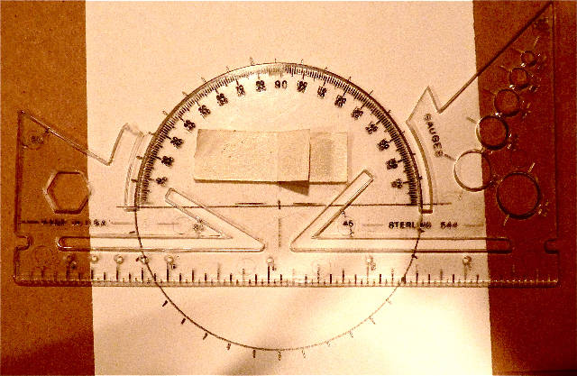
Stacking software has become widely used for making stacked images in photomicrography. Sacked images exhibit thin sections which are sharply focused in all parts. Objects such as bryophyte shoots photographed in reflected light have a three dimensional aspect. They can be very beautiful.

The software works best if photos are taken in evenly graduated, overlapping focal planes. When the overlap is optimal, about 25%, neither too many nor too few pictures need be taken. Precise, expensive, equipment is available that performs this process automatically. Obtaining excellent results by careful manual focusing is easily managed. I have installed a handmade metering dial on my microscope that has served well in this regard.

Draw a circle on a card and divide it into 10 degree segments using a protractor. Pencil in the radii for each segment. There is nothing special about 10 degrees; it is simply convenient and easy to see for this process.

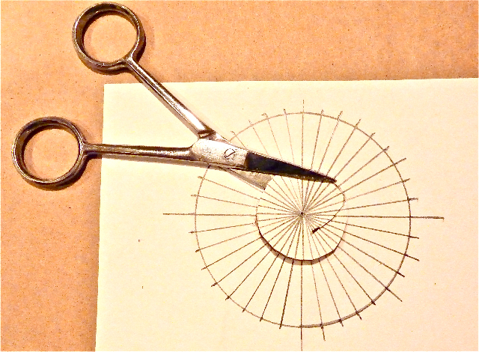
Cut out the center of this dial at a diameter that will fit around the fine focus knob on one side of the microscope.

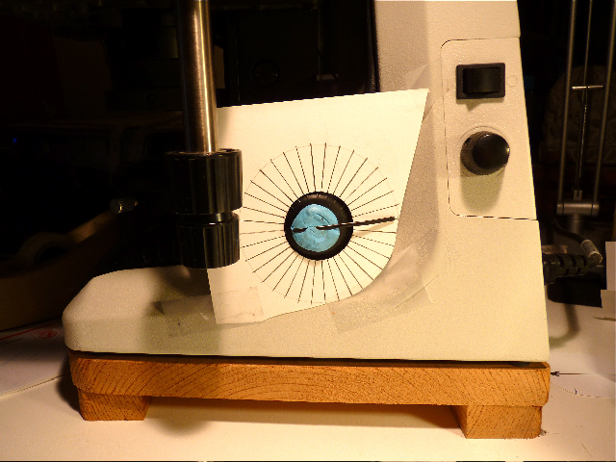
(Figure 3) Trim the card and tape it to the microscope so that the fine focus knob is centered in the middle of the dial. Attach a needle to the center of the knob, so that it reaches to the edge of the dial. I have used artist's putty and a piece of black binding tie that comes with power cords. Plastiline modeling clay and a toothpick would work about as as well.
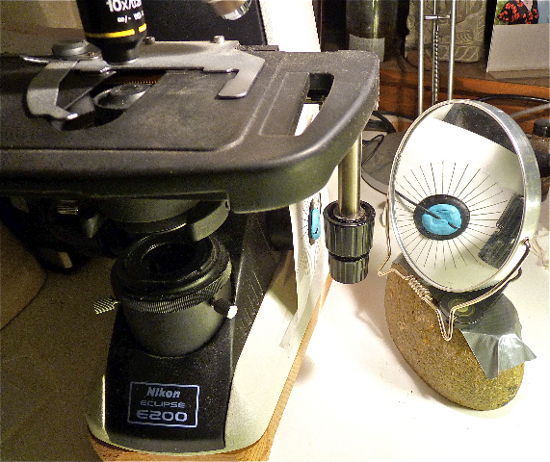
(Figure 4) Mount a mirror in such a way that the needle and dial are visible from your working position. This may not be necessary for all workers, but I like to be able to monitor the view through the microscope, adjusting focus with one hand while taking photographs with the camera's remote shutter release in the other hand.

For any particular object, I first determine how many turns around the dial are necessary for a complete series of images. I focus on the top of the object, note where the needle is on the dial, and then focus down to the lowest focal plane I want to capture. For most slide mounted objects I find the needle makes between one and three complete revolutions around the dial as I focus from top to bottom focal planes.

Experimentation is necessary to use this system effectively. I have found that with my Nikon Eclipse E200 microscope and a Nikon Coolpix camera, focus levels that work well are:

4X objective: 6 increments of the dial per image.
10 X objective: 2 increments of the dial per image.
40X objective: 0.5 increments, or even better is to take three images per increment. (Oil-bodies in liverwort cells come into and out of focus with very slight touches of the fine focus knob.)

Practice makes for consistent results. These guidelines provide about 25% overlap, which Helicon Focus, the program I currently use, seems comfortable with. Maximum resolution settings on the camera helps the stacking program to work optimally.

Once the object is properly staged, I simply keep an eye on the dial and my ear on the shutter sounds. I turn the knob for the pre-determined number of increments with my left hand on the fine focus knob, then activate the shutter release with right hand, turn the focus to the next stop, push the shutter release, etc., until I have completed the number of revolutions of the needle on the dial to make a complete set of images from top focus to bottom focus.

It is normal to work with ten to thirty images for slide preparations of bryophyte subjects. Digital photography allows the safety of overshooting the mark at both beginning and end of a stacking run. Useful images are exported to the stacking program. A stacked image is prepared for final presentation in PhotoShop or other favored image management software.

NEW LIGHT SOURCE FOR LAB AND FIELD

Development of LED lamps has resulted in amazing products appearing on the market. I have been most impressed with the intensity of the new lights now marketed as headlamps for bicyclists. These are intended to be mounted on handlebars or the top of helmets. Not only do they alert oncoming traffic to the rider, they are bright enough to serve as truly effective headlights, almost as bright as those for automobiles.

Although these lights may be expensive, they are not as expensive as a ring flash. The 250 lumen Cygolite I am experimenting with cost $130. Some of the models I've seen in cycling stores have up to a 400 lumen rating, but cost about a dollar per lumen. Eventually, as production volume increases the costs should come down.
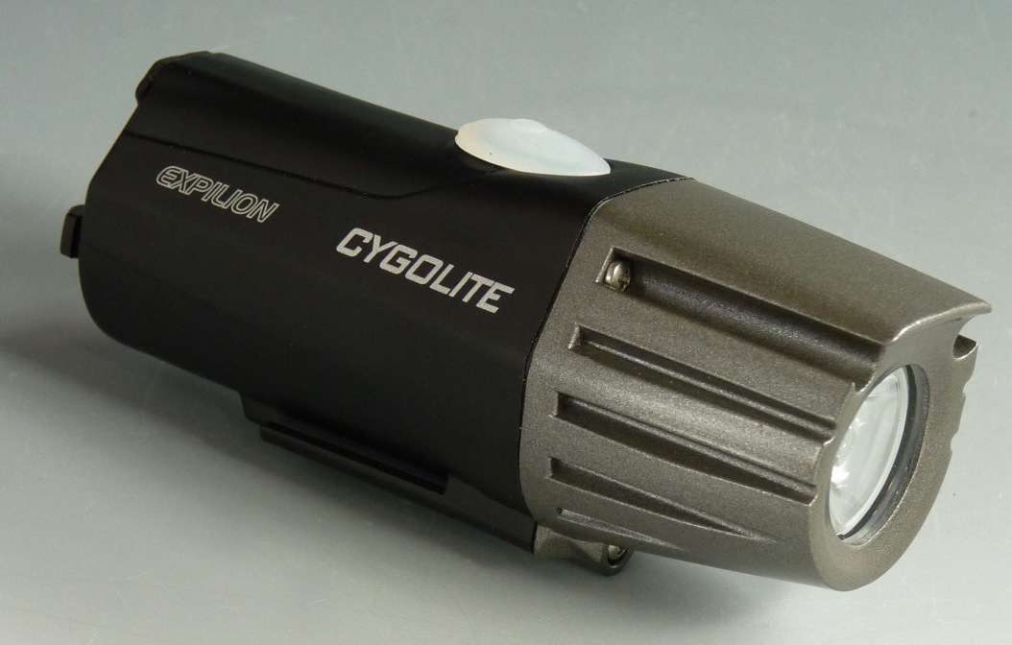
These lamps are compact (10 cm long, 4 cm diameter) with a rechargeable battery that plugs into either a wall receptacle or a computer's USB port. The latter is very useful because it means it can recharged it on a bench without looking for the wall outlet. Once charged, it can be moved from dissecting scope to compound scope easily because no wires tether it. The batteries are rated to have a five hour working time per charge, making the light useful for extended field work. The light can be directed on a colony of bryophytes in a dark forest. Having a steady light source, an image can be composed in a way not possible with a flash.
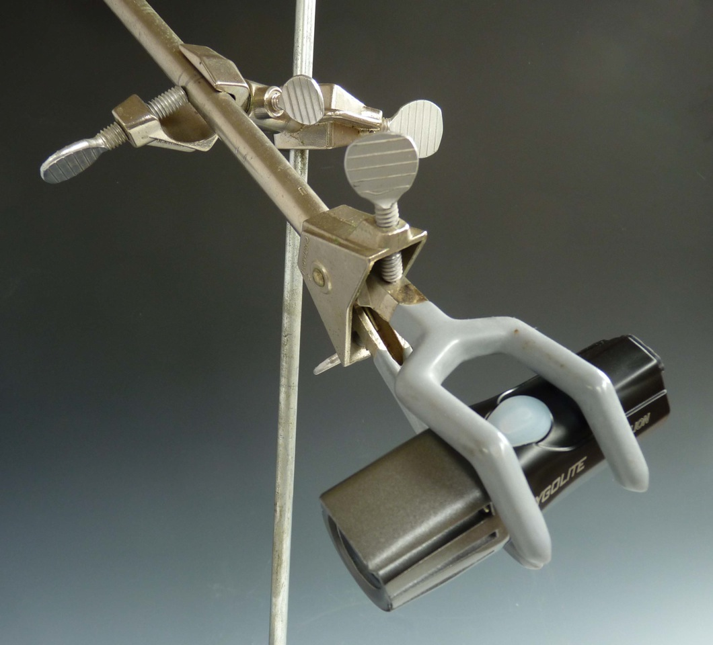
Because the light is bright enough to be mounted some distance from an object, the light doesn't cause the glare of fiber optic sources, yet is as cool as fiber optic sources. It is useful in adding reflected light to images made with compound microscope thanks to stacking software. Compare the two images of Jungermannia atrovirens androecia, one with transmitted light and the second supplemented by reflected light from a LED headlamp.

.
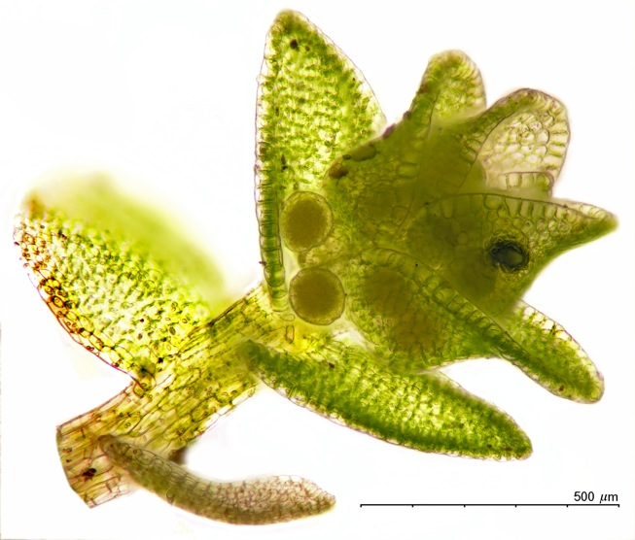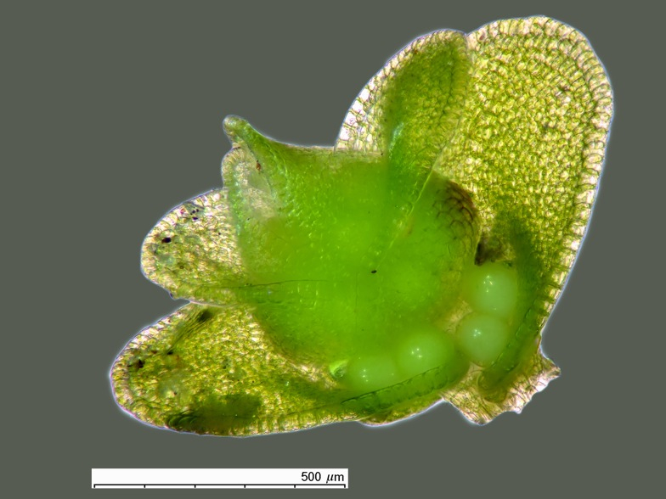
Left: transmitted light. Right: transmitted + reflected light.

INSERTING SCALES INTO IMAGES

A critical resource not commercially available is a set of scales to use for various magnifications. I'll attach the page I've assembled. Copy it to a safe, easily located place on your hard drive. Here's an outline of my process.

In Photoshop I open three files:
1. the page with scales,
2. the subject, and
3. an image of a stage micrometer at the same magnification as the subject.(I photograph a stage micrometer at every photo session, all the magnifications used in that session.)

Bring #1 to the top and select the appropriate scale. (The top one, 100µm, I use only with highest magnification (40X objective), middle ones for 10X objective, and bottom ones for 4X and multi-image mosaics.)

Copy the selected scale to the clipboard.

Bring #3 to the top and paste the copied scale onto the micrometer image. (see Picture 1, attached).

Use move tool (in PhotoShop CS3 you need also to set the move tool with Edit/Transform/Scale) to adjust the scale to the micrometer. (See Picture 2)

Flatten layers.

Select the calibrated scale and paste it onto the subject image. Remember: never resize images before the calibrated scale is pasted in!

I'd be happy to improve this set of instructions if something isn't clear. Others have asked and I should have a standard protocol to share.

